BASANT VALLEY PUBLIC SCHOOL
PLOT NO – 119, SEC – 46 GURGAON
CLASS – 2nd
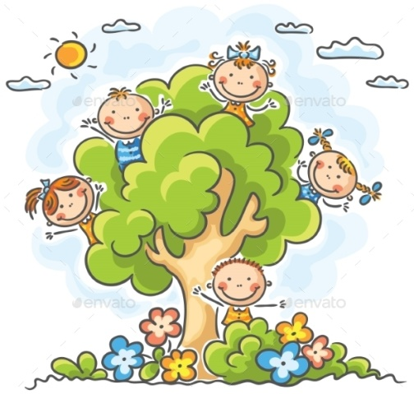
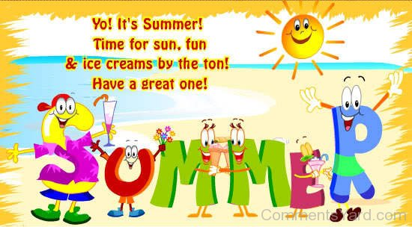

Note – Summer Vacation will start from 13th May 2017 and school will reopen on 3rd July 2017.
Kindly submit the Holiday Homework by 6th July 2017.
Dear Parent
We know you are looking forward to spend some constructive time with your child during the summer vacations. Here are some of the fun-filled activities to utilize your valuable time. We hope that you enjoy doing each activity with the child and make the holidays fruitful and exciting.
Some of the suggested activities for your child are:-
1. Get up early in the morning and see the rising sun.
2. Go for a nature walk
3. Feel the fresh air- Take a deep breath and do breathing exercise.
4. Hear the birds chirping.
5. Water the plants and feed the birds.
6. Take the child for a visit to Doll’s Museum/Rail Museum.
7. Take your child out for boating and Metro Ride.
8. Whenever you are going for an outing with your child make sure you discuss about the surroundings and have an open conversation with him/her.
TIPS FOR SUMMER BREAK
Dos Donts
Always start your day with prayers. Don’t watch TV for long hours
Drink lots of liquids like water, juice etc. Don’t eat junk food.
Wear cap and carry an umbrella when you move out day time. Don’t play in sun
Help your parents at home by putting your things in place.
Wish your elders and guests.
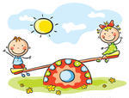
Always use these words – Thank you, sorry, Please, Excuse me.

“Happy Summer Break”

“Sandy Toes, Sunburned Nose, Summer Is A Blast, The Memories Will Always Last”
COMPUTER:
- Write few lines about laptop and palmtop with pictures on A4 coloured sheet.
- Solve the puzzle.
-----------------------------------------------------------------------------------------------------------------------------
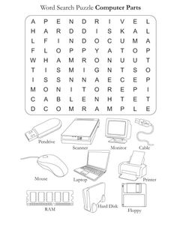

---------------------------------------------------------------------------------------------------------------------
EVS:
- Make a family tree & mention their birthdays.
- Learn chapter 1, 2 & 3 for class test.
- Paste or draw 10 pictures of body parts & write their functions also.
- In another A-4 sheet paste pictures of all sense organs & write their function also.
Note - All work should be done in colourful A-4 size sheet.
--------------------------------------------------------------------------------------------------------------------
English:
All work should be done coloured A4 size sheet.
- Take 20 words from lesson - 3 and arrange them in alphabetical order.
- Write 5 sentences about
- Your favourite toy
- Your favourite subject
- Draw the picture of the poem ‘The Swing’ and write the poem.
---------------------------------------------------------------------------------------------------------------------------
Hindi:
- “kCn HkaMkj fodflr djus ds fy, fdUgh nl “kCnkas dk fp= lfgr vaR;k{kjh ,3 lkbt “khV ij fy[ksA
- tUefnu fo’k; ls lacf/kr lkexzh dk fp= cukdj ,3 “khV ij fpidk,A
- 20 lqys[k fy[kks ¼dkWih esa fy[ks½
---------------------------------------------------------------------------------------------------------------------------
Maths:
Q.1. Write numerical for the following:
1) Seventy five _____________
2) Ninety nine ______________
3) Forty eight ______________
4) Thirty three ______________
Q.2. Write the missing number:
1) 5, 10, 15, ______, ______, ________
2) 8, 16, 24, ______, ______, ________
Q.3. Write the correct number:
1) 48 is just after ____________
2) 90 is just before ___________
3) 7 is in between ________ & _______
Q.4. Add the following –
a) 17 + 8 = _________
b) 15 + 5 = __________
c) 5 +5 = __________
d) 10+5 = __________
Q.5. Find the sum –
a) 6 9 b) 6 4 c) 7 9
+ 7 2 + 2 4 + 1 2
_________ _________ _________
__________ _________ __________
Q.6. Subtract the following
a) 4 7 b) 7 9 c) 6 9
- 2 8 - 0 9 - 5 8
____________ ____________ _____________
_____________ _____________ _______________
d) 4 9 e) 5 0
- 3 9 - 1 2
____________ _____________
_____________ _______________
Q.7. Paste any three articles each of rectangle, square, triangle, cone, cylindrical & sphere. You can use stick or paper for this. NOTE: Do above all work in class work note book.

